Forms of Assessment

Type |  | Purpose | Example | Advantages | Disadvantages
Diagnostic |  | Used BEFORE INSTRUCTION to determine students’ prior knowledge. | Unit Pre-Test | Helps to determine strengths and weaknesses that will assist a teacher in planning more effective lessons. | Takes up instruction time; Cannot be used to impact student’s grade; Student may not put forth much effort on assessment.
Formative
Summative
Alternative/ Authentic
Standardized | Norm-Referenced
 | Criterion-Referenced

Works Cited

***Rules of Works Cited page MLA Style***
- Double-space entire page (Do not add any extra space between entries – keep to normal double space type)
- Use a hanging indent for all entries (first line on the margin; additional lines are indented 0.5 inch)
- Alphabetize your entries by the last name of the author. If no author, alphabetize by title.
- One inch margins (left, right, top, and bottom).

Be sure to delete the rules above, this line, and graphic below before submitting your assignment.

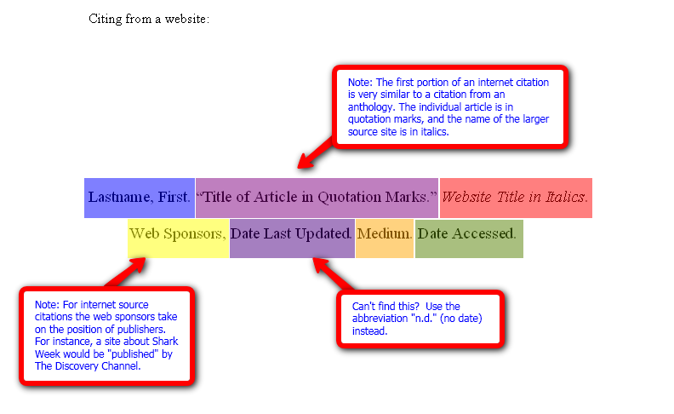
http://www.roanestate.edu/owl/images/MLA-APA/Citing_an_Article_from_a_Website-_MLA.png

Student:
FORMS OF ASSESSMENT
Rubric – Table or Infographic
*Turn In With Your Assignment*
Criteria | Points Possible | Student Assessment | Points Earned
Purpose / Description of each form of assessment (4 points each) | 20
Example provided for each type of assessment (4 points each) | 20
Researched and reasonable advantages given for each type of assessment (4 points each) | 20
Researched and reasonable disadvantages given for each type of assessment (4 points each) | 20
Works Cited page in proper MLA formatting (hanging indent, 1” margins, double-spaced, etc.) | 20
 | 100
COMMENTS:

