Classroom Management Techniques

Technique | Description | Pros | Cons
Proximity | Teacher walks around the class whether during instruction or while students are working in order to minimize behavior and to keep students engaged. | Teacher is always aware of what is going on in the classroom as he/she walks around. Teacher can minimize behavior by walking/standing near those students who may be off task. | A teacher cannot be in all places at one time, so there will be students (typically, furthest from the teacher) who may still misbehave.  Layout of the classroom may not allow for ideal proximity.

Works Cited

***Rules of Works Cited page MLA Style***
- Double-space entire page (Do not add any extra space between entries – keep to normal double space type)
- Use a hanging indent for all entries (first line on the margin; additional lines are indented 0.5 inch)
- Alphabetize your entries by the last name of the author. If no author, alphabetize by title.
- One inch margins (left, right, top, and bottom).

Be sure to delete the rules above, this line, and graphic below before submitting your assignment.

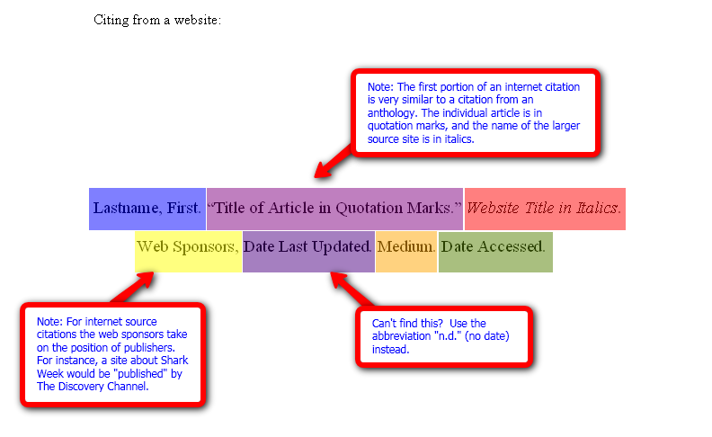
http://www.roanestate.edu/owl/images/MLA-APA/Citing_an_Article_from_a_Website-_MLA.png

Student:
CLASSROOM MANAGEMENT
Rubric – Table (OR Video)
*Turn In With Your Assignment*
Criteria | Points Possible | Student Assessment | Points Earned
FIVE additional classroom management techniques were given. | 25
A full description of technique is given that any reader could understand. | 25
Reasonable and researched pros for each technique are given. | 15
Reasonable and researched cons for each technique are given. | 15
Resource / Works Cited Page with proper formatting | 20
TOTAL | 100
COMMENTS:

